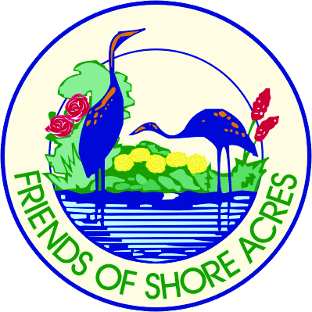
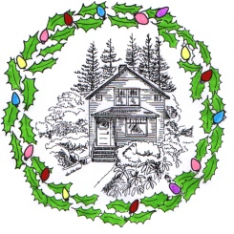
SHORE ACRES STATE PARK IS A NON-SMOKING VENUE
Volunteers may smoke only in the confines of their vehicles only.

Shore Acres Holiday Lights Scheduled Entertainment 2019
(As of Nov. 25 and Subject to Change)

Date Day Time Group Name

Dec 3 Tuesday 7:30 PM Gold Coast Chorus

Dec 4 Wednesday 5:30 PM Charleston Community Baptist Church

Dec 9 Monday 5:30 PM Marshfield High School “New Horizons”

Dec 10 Tuesday 7:30 PM Pacific Community Church

Dec 11 Wednesday 7:30 PM Lighted Hula Hoops

Dec 12 Thursday 5:30 PM Kingsview Christian Church

Dec 12 Thursday 7:30 PM Bay Area Hospital

Dec 16 Monday 5:30 PM Bandon Carolers

Dec 17 Tuesday 5:30 PM Sea Breeze Harmony Chorus

Dec 17 Tuesday 7:30 PM Side of the Tide-Morris Dance Group

Dec 18 Wednesday 5:30 PM Bay Area Concert Band

Dec 18 Wednesday 7:30 PM The Grinch & The Whoville Carolers

Dec 19 Thursday 7:30 PM Saints-n-Aints Square Dancers

Dec 23 Monday 7:30 PM Lighted Hula Hoops

